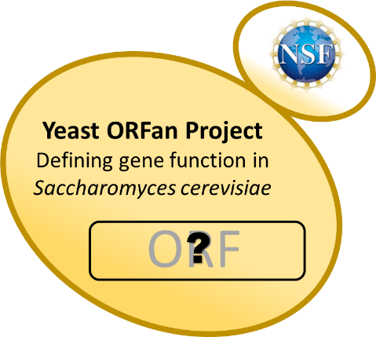
The Yeast ORFan Gene Project
An NSF-funded Research Coordination Network

- Are you interested in implementing a Course-based Undergraduate Research Experience in your class?
- Do you want to establish a collaboration with others in the yeast field and get access to more resources?
- Do you want to start to new research projects in your lab?
- Are you looking to learn new techniques or a new model system?

Join us for the summer 2018 workshop
June 11th-June 15th, 2018
at Rhodes College in Memphis, TN
Travel, room and board covered for all accepted participants
The 2018 workshop wet lab focuses on transcriptional reporters
with opportunity for RNA-Seq analysis

To apply, save this file with your last name_initials at the beginning of the filename (e.g. Keeney_JB-2018 NSF RCN-UBE yeast ORFan workshop application). Complete each of the questions below, and email to Jill Keeney at keeney@juniata.edu.
Application of teams-faculty and an undergraduate student-is encouraged, but not required. Inter-institutional teams are also encouraged. Please read the workshop description at http://www.yeastorfanproject.com/ for more details.
A. Contact Information.
Participant 1  Name:  Department:  Institution:  Address:  Phone Number:  Email Address: | Participant 2 if a team –  faculty undergraduate (circle one)  Name:  Department:  Institution:  Address:  Phone Number:  Email Address:

B. Background and Experience
- What courses do you currently teach?

- Briefly explain how, at your institution, you might be able to incorporate yeast genetics into your teaching.

- Do you have experience in yeast biology? (previous experience not a requirement for participation. This information helps with workshop planning.)

- Do you have experience mentoring undergraduate research? (previous experience not a requirement for participation. This information helps with workshop planning.)

- The ORFan gene project defines an ORFan as: "GO term with “no known function” in either molecular function or biological process". Other genes could be defined as appropriate for network involvement based on available information. Briefly describe your area(s) of biological interest and expertise and give a list of at least three ORFans genes that you are interested in studying. [See the document "Identifying ORFans on the ORFan project web site. If you need help, contact Jill Keeney at keeney@juniata.edu.]
- In one page or less, explain why you would like to attend the workshop, including how it will benefit your academic and/or professional development and your department.

C. Agreements
- I agree to hold a teleconference with other attendees from the workshop or in the ORFan gene network during the academic year following the workshop. ☐yes

- If I offer a course using network resources during the 2018-2019 academic year, I agree to administer the yeast ORFan pre- and post-activity assessment test for students and to complete the faculty post-utilization survey ☐yes

- I have signed up for the yeast ORFan network membership at http://www.yeastorfanproject.com/. ☐yes

D. Please include a CV. If you propose to come with a student, please write a paragraph attesting to the student’s career interest, academic capacity, and leadership potential.

