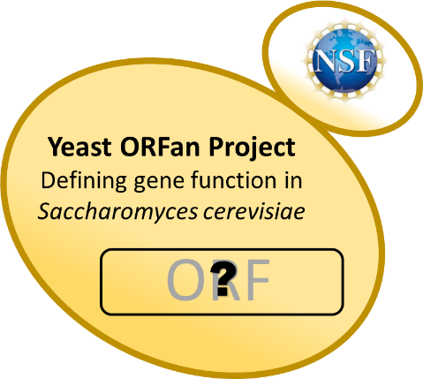
The Yeast ORFan Gene Project
An NSF-funded Research Coordination Network
http://www.yeastorfanproject.com/
- Are you interested in implementing a Course-based Undergraduate Research Experience in your class?
- Do you want to establish a collaboration with others in the yeast field and get access to more resources?
- Do you want to start new research projects in your lab?
- Are you looking to learn new techniques or a new model system?
Join us for the final workshop, summer 2022!
June 13-18, 2022
at Ohlone College Newark Campus 39399 Cherry St,. Newark CA 94560
39399 Cherry St., Newark, CA 94560

Travel, room and board covered for all accepted participants

The 2022 workshop provides opportunities for collaboration with other educators while planning for use of Course-based Undergraduate Research Experiences (CUREs) investigating gene function in yeast through bioinformatics and wet lab modules. The wet lab will include construction of deletion mutants, screening of selected phenotypes. Additional sessions include assessment, implementation and publication.

To apply, save this file with your last name_initials at the beginning of the filename (e.g. Keeney_JB-2022 NSF RCN-UBE yeast ORFan workshop application). Complete each of the questions below, and email to Jill Keeney at keeney@juniata.edu. Application review will begin February 15, 2022 and continue until the workshop is filled (24 total participants).
Application of teams (faculty and an undergraduate student or pairs of faculty) is encouraged, but not required. Inter-institutional teams are also encouraged.
A. Contact Information.
Participant 1  Name:  Department:  Institution:  Address:  Phone Number:  Email Address: | Participant 2 if a team –  faculty undergraduate (circle one)  Name:  Department:  Institution:  Address:  Phone Number:  Email Address:

B. Background and Experience
- What courses do you currently teach?

- Briefly explain how, at your institution, you might be able to incorporate yeast genetics into your teaching.

- Do you have experience in yeast biology? (Previous experience is not a requirement for participation. This information helps with workshop planning.)

- Do you have experience mentoring undergraduate research? (Previous experience is not a requirement for participation. This information helps with workshop planning.)

- The ORFan gene project defines an ORFan as: "GO term with “no known function” in either molecular function or biological process". Other genes could be defined as appropriate for network involvement based on available information. Briefly describe your area(s) of biological interest and expertise and give a list of at least three ORFans genes that you are interested in studying [http://www.yeastorfanproject.com/orfans/.] Study of "adopted ORFans" is perfectly fine [http://www.yeastorfanproject.com/orfans/adopted-orfans/ ]. If you need help or have questions, contact Jill Keeney at keeney@juniata.edu.

- In one page or less, explain why you would like to attend the workshop, including how it will benefit your academic and/or professional development and your department.

- Are you interested in obtaining RNA-Seq data on your selected ORFs? If yes, briefly explain what question(s) you hope to address with an RNA-Seq data set.

C. Agreements
- If I offer a course using network resources during the 2020-2021 academic year, I agree to administer the yeast ORFan pre- and post-activity assessment test for students and to complete the faculty post-utilization survey ☐yes

- I have signed up for the yeast ORFan network membership at http://www.yeastorfanproject.com/. ☐yes

D. Please include a CV. If you propose to come with a student, please write a short paragraph describing the student’s career interest, academic capacity, and leadership potential.

